STORY A: BIRDS HAVE TO FLY!
CUENTO A: ¡LOS PÁJAROS DEBEN VOLAR!

This is the story of a bird that wanted to travel around the world, but he couldn’t fly. His name was Red, he was big, funny, and kind and he had different colours in his body, like a parrot. His eyes were blue and they were a special shine.
His friends gave him flying lessons, but they didn’t know how to make him fly and he fell down once and again.
His friends’ names were Tom, Rose and Mathew. Tom was a fat and red bird, Rose and Mathew were little and blue. They were a perfect team, because they were all different but they always helped each other.

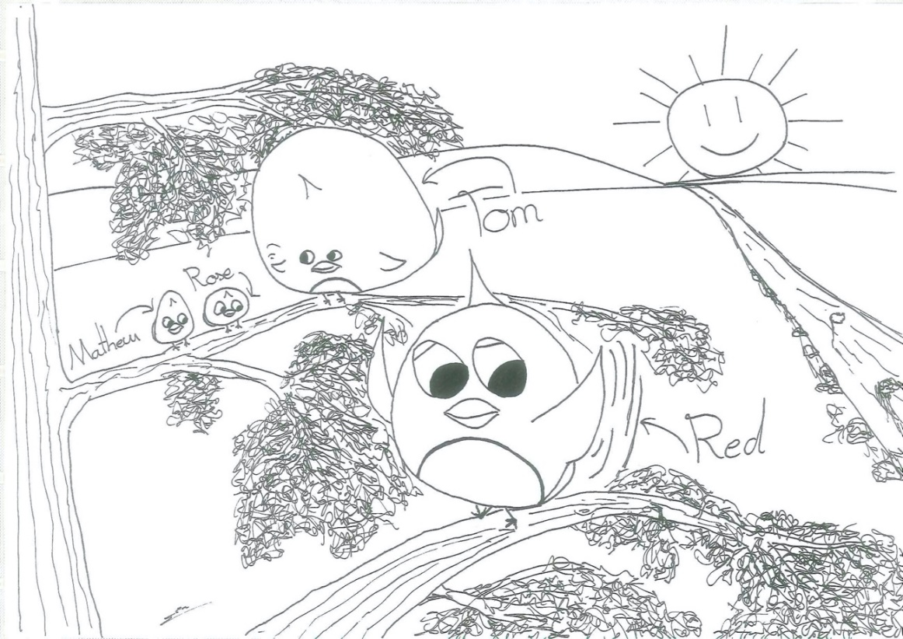

Esta es la historia de un pájaro que quería viajar alrededor del mundo, pero no sabía volar. Se llamaba Red, era grande, divertido, amable y tenía el cuerpo de diferentes colores, como un loro. Tenía los ojos azules y con un brillo especial.
Sus amigos le daban clases de vuelo, pero no lograban hacerle volar y se caía al suelo una y otra vez.
Los nombres de sus amigos eran Tom, Rose y Mathew. Tom era un pájaro gordo y rojo, Rose y Mathew eran pequeños y azules. Todos formaban un equipo perfecto, porque eran diferentes, pero siempre se ayudaban los unos a los otros.
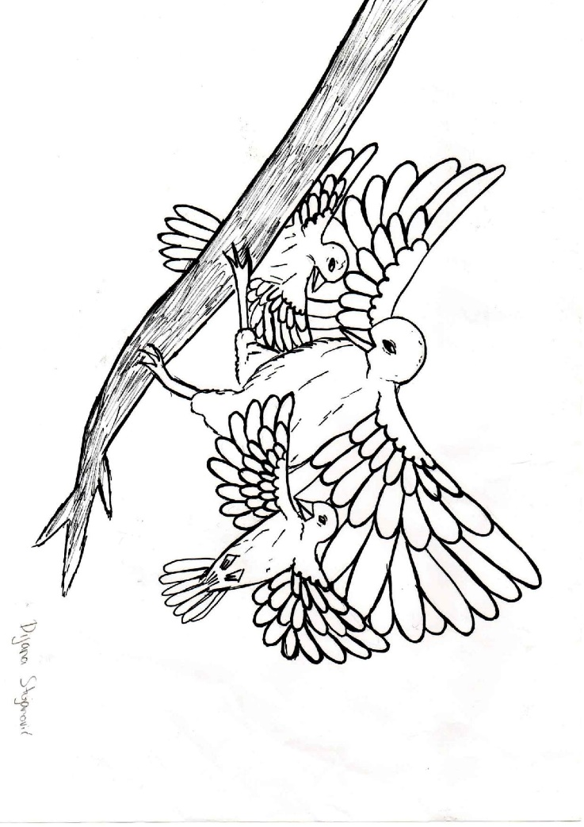
They have been helping Red for a long time. A few days later a group of birds appeared on the branch. They looked sullen and violent. They were unusually coloured feathers with a dangerous look. Red continued to study as if they were not there. He was trying to take off, because what is a bird if he cannot fly. He fell many times, but also got up. The group from the branch scoffed at the unfortunate Red. After that, Red and friends left because they could no longer listen to the insults. They agreed to show what they could do tomorrow. The next day Red began… and fell. He was sad. He repeated the run, but now his blue friends went under his wings and took off. That's how he succeeded! The group from the branch watched the scene in astonishment. They left so as not to look at their wrong assumption.
Dugo vremena su pomagali Redu. Nekoliko dana kasnije na grani se pojavila skupina ptica. Izgledali su mrzovoljno i nasilnički. Bili su nesvakidašnjih boja perja s opasnim pogledom. Red je nastavio učiti kao da njih nema. Pokušavao je poletjeti, jer što je ptica ako ne zna letjeti. Puno puta je padao, ali i ustajao. Skupina sa grane se podsmjehivala nesretnom Redu. Nakon toga su Red i prijatelji otišli jer više nisu mogli slušati vrijeđanje. Dogovorili su se da će sutra pokazati što umiju. Idućeg dana Red je počeo… i pao. Rastužio se. Ponovio je zalet, ali sada su njegovi plavi prijatelji otišli ispod njegovih krila i poletjeli. Tako je i on uspio! Skupina s grane je začuđeno promatrala prizor. Otišli su kako ne bi gledali svoju krivu pretpostavku.
After flying for almost an hour, Rose and Mathew got too tired to keep flying under Red’s wings. Therefore, they all stopped on a rooftop of a quaint two-story log house. The house was atop of a quiet and serene hill. The beautiful village at the mountain foothills, and the house’s small apple orchard matched its charm. Deciding to do something useful, Tom decided to go and collect some apples to feed their stomachs. Red looked at his remaining friends and got sad. He felt bad that his friends had to do so much to help him. He wanted to show everyone, that his efforts were not in vain...

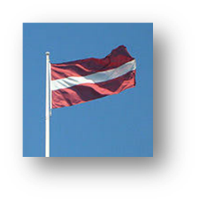
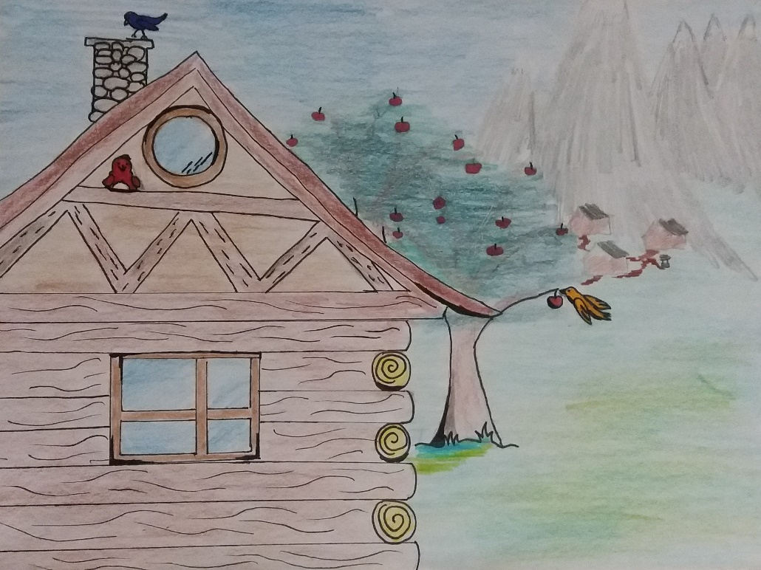
Pēc gandrīz stundu ilgas lidošanas, Roza un Metjū kļuva pārāk noguruši, lai turpinātu lidot zem Reda spārniem. Tā nu viņi visi apstājās uz kādas šarmantas divstāvu baļķu mājas jumta. Māja atradās pavisam mierīgā pakalnā. Tā šarmu papildināja burvīgs ciemats kalna pakājē un mājas mazais ābeļdārzs. Nolēmis izdarīt kaut ko lietderīgu, Toms nolēma doties un salasīt dažus ābolus, lai pabarotu viņu visu vēderus. Reds paskatījās uz saviem palikušajiem draugiem un kļuva bēdīgs. Viņam bija žēl, ka draugiem bija jādara tik daudz, lai viņam palīdzētu. Viņš gribēja visiem pierādīt, ka viņu pūles nav bijušas veltas...
He tried for the last time, fell to the ground, and failed again. He was too disappointed he didn't even get up. He was laying there for a couple of minutes. Until something in his head clicked, he realised if he isn't going to try and success today he is never going to be able to fly. He was so sure that he tried again.
Moreover, this time for real. He went to the top of the house roof, prepared himself, and started running towards the end of the roof. Finally, when his last leg left the roof his wings opened and he started to fly. It was so beautiful that all of his friends just stared at him. Tom almost dropped all of the apples cuz he was so surprised that his friend finally succeeded. Everyone was just stunned. They all started to cheer up Red. However, Red he felt like never before. The feeling of joy finally filled up his heart.
In the end, they all happily flew away towards the sun. They were all happy like never before because his friend Red finally succeeded.
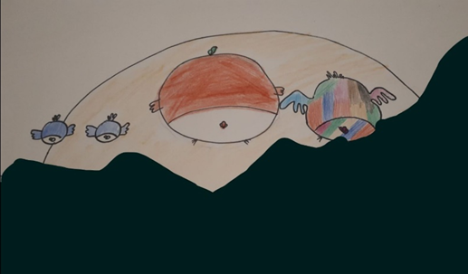

Poskusil je še zadnjič a na žalost padel na tla. Bil je tako razočaran, da se ni niti pobral. Tako je ležal na tleh za nekaj minut. Dokler mu nekaj v glavi ni kliknilo, ugotovil je, da če mu ne uspe danes mu ne bo nikdar. Bil je tako prepričan, da je poskusil še enkrat tokrat zares.
Odšel je na streho hiše, se pripravil, začel tekati proti koncu strehe in ko je njegova zadnja noga zapustila streho je odprl krila in začel leteti. Bilo je tako lepo, da so ga vsi njegovi prijatelji samo gledali. Tom je skoraj spustil na tla vse njegove jabolke, ker je bil tako presenečen, da je njegovemu prijatelju končno uspelo. Vsi so bili tako zelo osupnjeni. Začeli so ga spodbujati in ploskati. Ampak Rdeči, on se je počutil tako kot nikdar prej. Občutek veselja mu je končno zapolnilo srce.
Ob koncu so vsi veselo odleteli proti soncu. Vsi so bili tako veseli kot nikdar prej saj je Rdečemu končno uspelo.

