I fly, I fly and I still fly..

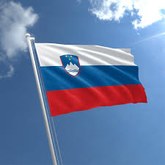
Letim, letim in še letim. Letim na sever, letim na jug, letim na vzhod in letim na zahod. Letim na vse strani našega širnega sveta. Ampak, da ne boste mislili, da toliko letim ves čas. Ne, samo pripravljam se na pravi pravcati 'predzimski južni maraton štorkelj', če se lahko tako izrazim. Ja, ste že ugotovili – štorklja sem. Sem ponosna štorklja, ki je bila izbrana za prav posebno nalogo – vodila bom štorklje na jug. Že v vrtcu ste se naučili, da vse štorklje, vsako leto – stare in mlade, male in velike, z dolgimi in še daljšimi kljuni– letimo na jug. In tako je tudi to leto, zato grem najprej po štorkljo Mici v Maribor, potem še po Lili v Ljubljano, skupaj gremo po Cici v Celje, po Koki v Kranj, kasneje pa še po Bruna, Jonasa, Olivijo, Emo, Danijela, Sofijo in še nešteto drugih. Tako se bomo skupaj odpravili na pustolovščino v tople kraje.
Iskreno povedano, je bila v zadnjih letih to res pustolovščina. Ampak ne mirna, polna zabave in smeha, temveč nevarna, strašna in polna adrenalina. Namesto, da bi med mirnim letom v južne kraje vonjale svež, hladen zrak, smo namesto tega vonjale smrdljiv zrak, ki nam je solzil oči in zapolnjeval kljune. Ahh, pa toliko letal! Saj se bom še kam zaletela! Se bom še izgubila med letom! Ko smo že pri tem … Vas zanima zgodba? Prav, vam jo bom povedala.
Bilo je pred dvema letoma, ko smo letele že dobra dva dni. Jadrale smo nad južno Evropo, ko se je zgodila tragedija; hotele smo malo postati in si odpočiti. Kot vedno, malo poklepetamo in se seveda preštejemo. Štorklja, ki nas je tisto leto vodila, nas je preštela trikrat, če ne celo štirikrat, a vedno je prišla do istega rezultata – eden je manjkal. Odrasle štorklje so začele klicati svoje mladičke, oni pa so pridno letali do mamic in očkov. Nastala je velika panika. Vsi so se spraševali, kako je to mogoče in kdo je ta, ki se je izgubil. Že smo hoteli vzleteti in oditi naprej, ko je nekdo zakričal: »Bill! Bill nam manjka!«.
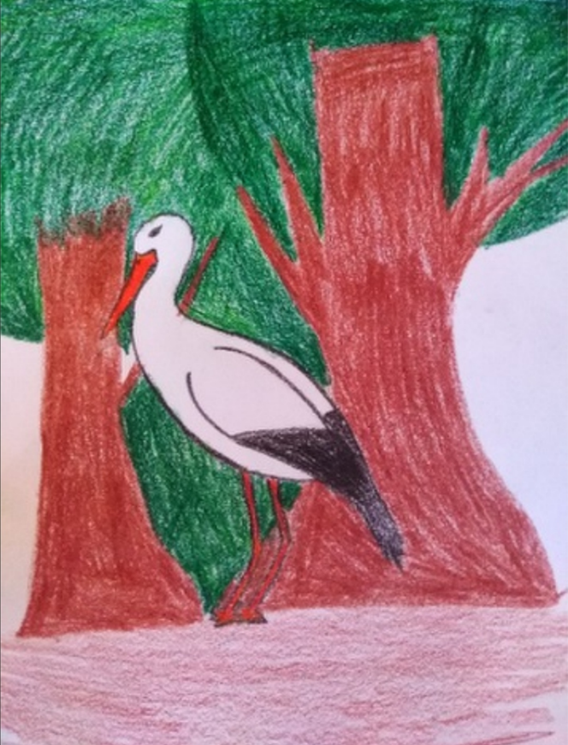
Bill pa je medtem žalostno taval po gozdu in globoko premišljeval, kaj naj naredi. Že se je želel pognati od tal in odpreti krila, ko je nekaj v grmu zašumelo in prikazala se je močna postava, ki je spominjala na … Oh oprosti, ampak morala bom iti. Žal bom morala zgodbo tukaj zaključiti, saj drugače štorklje ne bomo pravočasno prispele v tople kraje. Obljubim pa ti, da ko se naslednjič vidiva, ti zgodbo povem do konca. Obljubim! Do takrat pa adijo! Se vidimooo!
Kaj pa ti? Kaj pa ti misliš da se je zgodilo potem?

I fly, I fly and I still fly. I fly north, I fly south, I fly east and I fly west. I fly to all sides of our wide world. But that you won’t think I fly that much all the time. No, I’m just getting ready for a real ‘pre-winter Southern Stork Marathon’, if I may put it that way. Yeah, you already found out - I'm a stork. I am a proud stork that has been chosen for a very special task - I will lead the storks south. Already in kindergarten, you learned that all storks, every year - old and young, small and large, with long and even longer beaks - fly south. Therefore, it is this year, so I go first for the stork Mica to Maribor, then for Lili to Ljubljana, together we go for Cica to Celje, for Koka to Kranj, and later for Bruno, Jonas, Olivia, Emma, Daniel, Sofia and countless others. So together, we will go on an adventure to warm places.
Honestly, it’s been really an adventure in recent years. Nevertheless, not calm, full of fun and laughter, but dangerous, scary and full of adrenaline. Instead of smelling fresh, cold air to southern places during a calm flight, we instead smelled stinking air that made our eyes water and fill our beaks. Ahh, and so many planes! What, if we'll crash into something?! What, if we will lose ourselves? While we're at it… Are you interested in the story? Okay, I'll tell you.
It was two years ago when we had been flying for a good two days. We were sailing over southern Europe when the tragedy happened; we wanted to get up a little and rest. As always, we chat a bit and of course count. The stork that led us that year counted us three times, if not four times, but it always came to the same result - one was missing. Adult storks started calling their children, and they diligently flew to moms and dads. There was a great panic. Everyone wondered how this was possible and who was the one who got lost. We were about to take off and move on when someone shouted: »Bill! We miss Bill!
Bill, meanwhile, wandered sadly through the woods, pondering deeply what to do. Already wanting to run off the ground and open the wings, something in the bush rustled and a strong figure appeared, reminiscent of… Oh sorry, but I will have to go. Unfortunately, I will have to end the story here; otherwise, the storks will not arrive in warm places in time. However, I promise you that the next time we see each other; I'll tell you the story to the end. I promise! Until then, goodbye! See you!
What about you? What do you think happened then?

Bill nació en la primavera de ese mismo año. Era su primer vuelo largo y no tenía experiencia: al pasar por una nube oscura, pensó que eran nubes de lluvia. Pero perdiósu rumbo porque las nubes negras eran gases del avión que habíamos visto y por eso Bill acabó en el árbol.
Cuando se encontró con esa gran silueta, el estaba tan asustado que que quiso escapar tanrápido como le era posible y entonces es cuando se dio cuenta de que tenía una ala herida que no le dejaba volar. Afortunadamente, la silueta era un leñador que, viendo a Bill herido, se lo llevó a su caseta del bosque para curarlo.
La gran sorpresa de Bill fue que, al llegar a la caseta, vio a otra cigüeña que no pudo volar con su familia tampoco porque se hirió la pata justo un día antes de empezar el viaje. Poco a poco, Bill y Noa (que era el nombre de la otra cigüeña) se hicieron buenos amigos. Ella le preguntó a él si le gustaría continuar el viaje juntos. Bill respondió que sí. Salieron pronto esa mañana y después de un rato, vieron unos puntos negros en el cielo a lo lejos...
________________________________________________________________________
Bill was born in spring that same year. It was his first long flight and as he had no experience: passing through a dark cloud, he thought it was rain clouds. However, it lost its way because the black clouds were the gases from the plane we saw and that´s why our dearest Bill arrived at the tree.
When he met the "strong figure", he was so scared that he wanted to escape as fast as he could and that’s when he realized he had a wounded wing that didn’t let him fly. Luckily, the "strong figure" was a woodsman who, seeing Bill wounded, took him to his cabin in the woods to cure him.
Bill’s big surprise was that as soon as he got to the cabin, he saw another stork which couldn’t fly with his family either, because he had damaged his leg just a day before the trip. Passing the days by, Bill and Noa (that was the other stork’s name) became good friends. She asked him if he would like to continue the journey with her. Bill said ‘yes’. They left early in the morning and after a while; they saw some black spots in the sky far away…

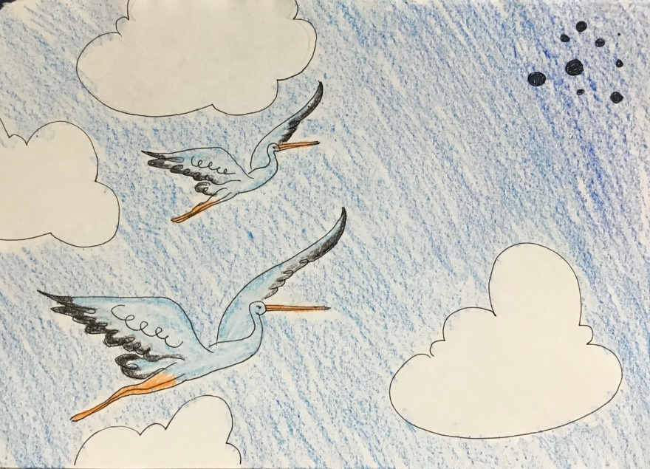

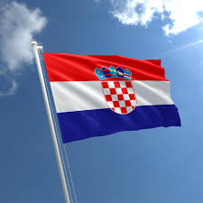
Bill i Noa su bili previše znatiželjni i odlučili doletjeti do tih crnih mrlja. Kada su se približili, shvatili su da je to bila zapravo grupa opakih crnih vrana. Dvije rode bile su previše mlade i neiskusne da bi se znale obraniti od ovih strašnih ptica. Skrili su se u oblake. Billa je zaškakljalo Noino pero, te je kihnuo. Kako je on kihnuo, tako je oblak eksplodirao i otkrio ih. Najstarija i najstrašnija vrana ih je opazila i naredila cijelom jatu da mu dovedu te dvije rode, jer su se one našle u njegovom nebeskom carstvu.

Bill and Noa were too curious and decided to fly to those black spots. As they approached, they realized it was actually a group of vicious black crows. The two storks were too young and inexperienced to know how to defend themselves from these terrible birds. They hid in the clouds. Bill was tickled by Noa's pen, and he sneezed. As he sneezed, so did the cloud explode and reveal them. The oldest and scariest crow noticed them and ordered the whole flock to bring him these two storks, for they had found themselves in his heavenly kingdom.
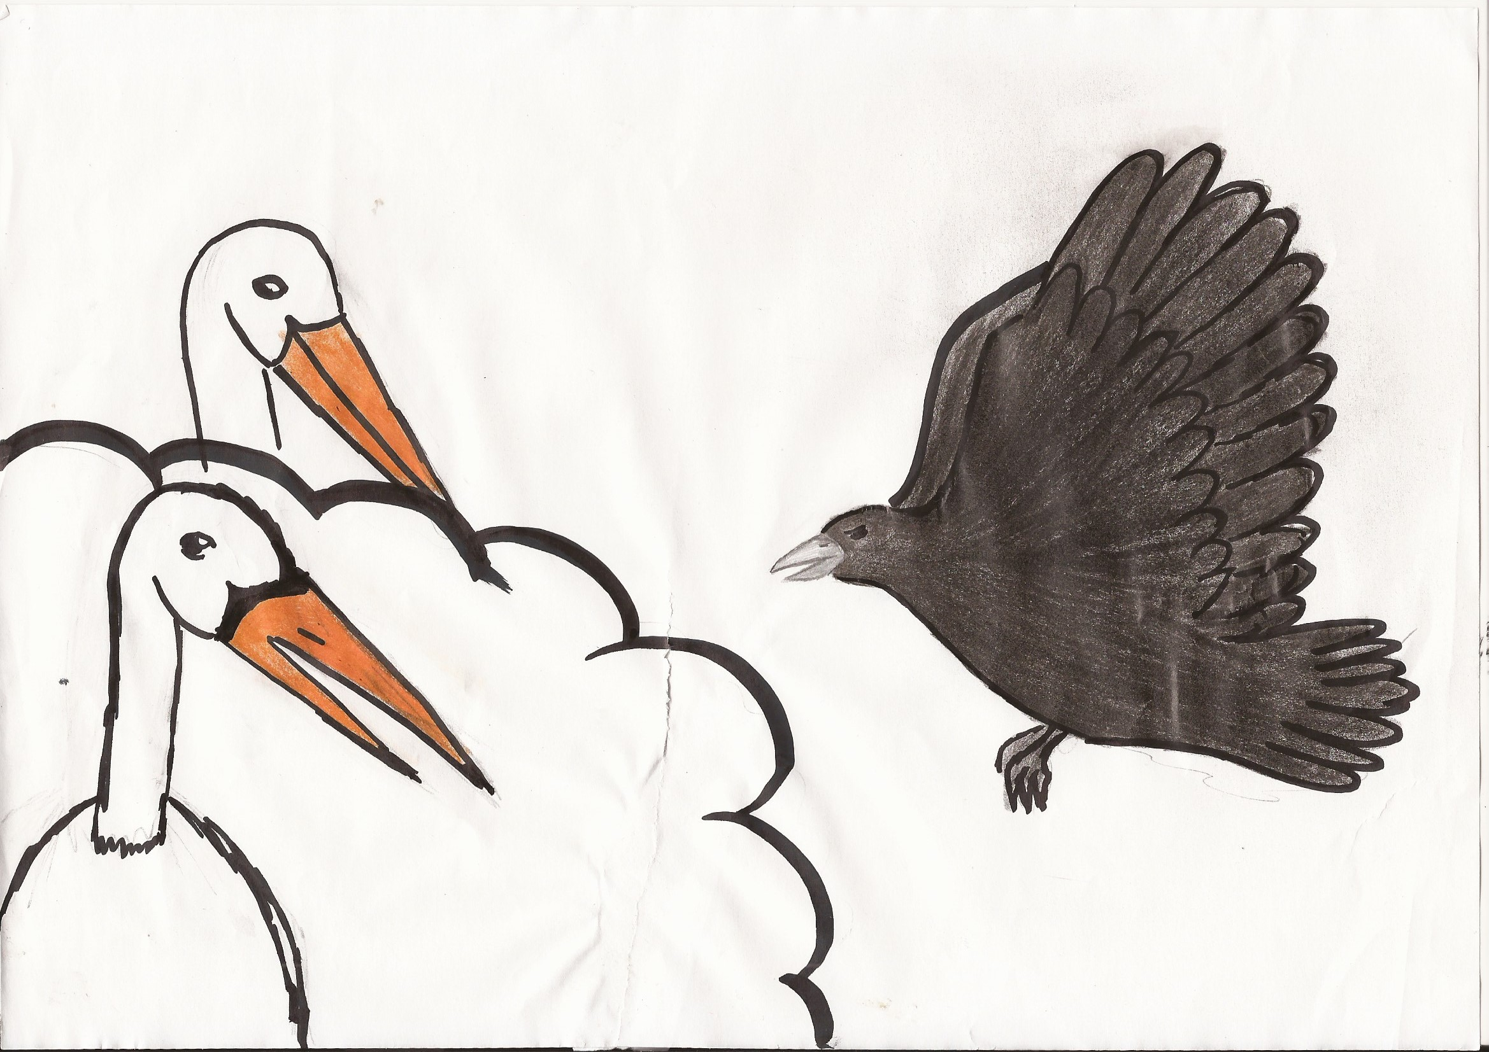

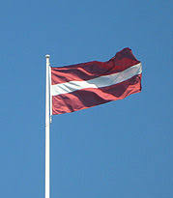
Vārnas pamatīgi nobiedēja stārķus. Vārnas lidoja pilnā ātrumā virsū nabaga stārķiem, un tie pamatīgi nobijās. Taču tad, kad vārnas bija atlidojušas pietiekoši tuvu, izrādījās, ka tās bija ļoti draudzīgas un nevēlējās nodarīt neko ļaunu. Sanāca tā, ka stārķi pat ļoti vēlējās iepazīt vārnas. Beigu beigās viņiem bija spēle, kura pārbaudīja vai tu esi labs draugs vai slikts draugs. Kā vārnas, tā stārķi ieguva 10 punktus šajā spēlē, kas pierādīja to, ka visi var būt labi draugi. Viņi pavadija daudz laiku kopā. Un palika par draugiem visu mūžu!

Crows really scared storks. Crows flew at full speed on the poor storks, and they got frightened. Yet, when crows were close enough, it turned out. They saw that crows actually are very friendly and they unwilling to do anything wrong or bad to them. The same thing about the storks. Storks even wanted to know better crows. Moreover, in the end, they had a game that tested if you were a good friend or you are not. Both the storks and crows got 10 points at that game, which showed and proving that everyone there could be a great friend.
They spent a lot of time together. Moreover, they became friends and they stayed for friends forever!
